# Seeing Into the Ground: Archeology and Magnetometry Student Handout

# Vocabulary

*Active method*: tools produce signals that are sent into the ground and record the response

*Anomaly*: positive or negative change of the geomagnetic field strength caused by an unknown source

*Archeology*: the scientific study of humans in the past

*Artifact*: an object created and used by ancient people

*Context*: where an object was found in the ground including depth and surrounding objects

*Excavation*: the scientific removal and recording of soil, artifacts, and features

*Feature*: as opposed to portable artifacts, these are the non-portable parts of an archeological site such as walls, hearths, or trash pits

*Gradiometer*: one type of magnetometer that contains two sensors used to measure the impact buried features have upon the geomagnetic field

*Geomagnetic field*: Earth’s natural magnetic field

*Geophysical*: scientific study of the physics of the Earth

*Magnetometry*: passive technique that measures variations within Earth’s geomagnetic field

*Magnetic field lines*: show a magnetic field’s direction and strength

*Non-invasive method*: scientific technique used to gather site data yet not requiring excavation

*Passive method*: tools rely on the variations of natural forces rather than producing signals

*Poles*: regions of a magnet where magnetic field lines meet

# Introduction

**Archeology** is the scientific study of humans in the past. Archeologists use both **artifacts**, or the objects made and used by past peoples, and **features** to understand daily life hundreds and even thousands of years ago.

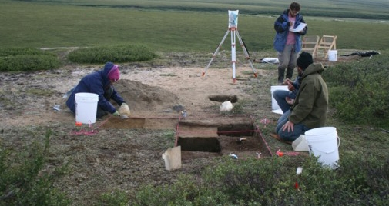

Archeological excavation. National Park Service.

Archeology is a physical science that often involves site **excavation**. While scientifically removing soil layers with trowels or shovels, archeologists record uncovered artifacts and features, their **context** including how deep in the ground they were and what objects they were next to, and what the surrounding soil looks like. This information helps archeologists tell the site’s full story, from when and how it was used to how it became buried.

However, archeologists can face multiple problems during these projects. First, before excavating, they must actually locate a site. This is often not a simple process. Some archeological sites are buried deep within the ground and no trace of them appears on the ground surface. Archeologists rely on historical documents, oral histories, and other clues to give them an idea of where a site might be. They must then use excavation as a guess-and-check method.

Second, archeological sites are *any* place that contains evidence of past human activity. This means that sites can be extremely small, such as the remains of a single house, or very large like ancient cities that cover miles. Often, archeologists do not have the funds or the time to complete excavate large sites.

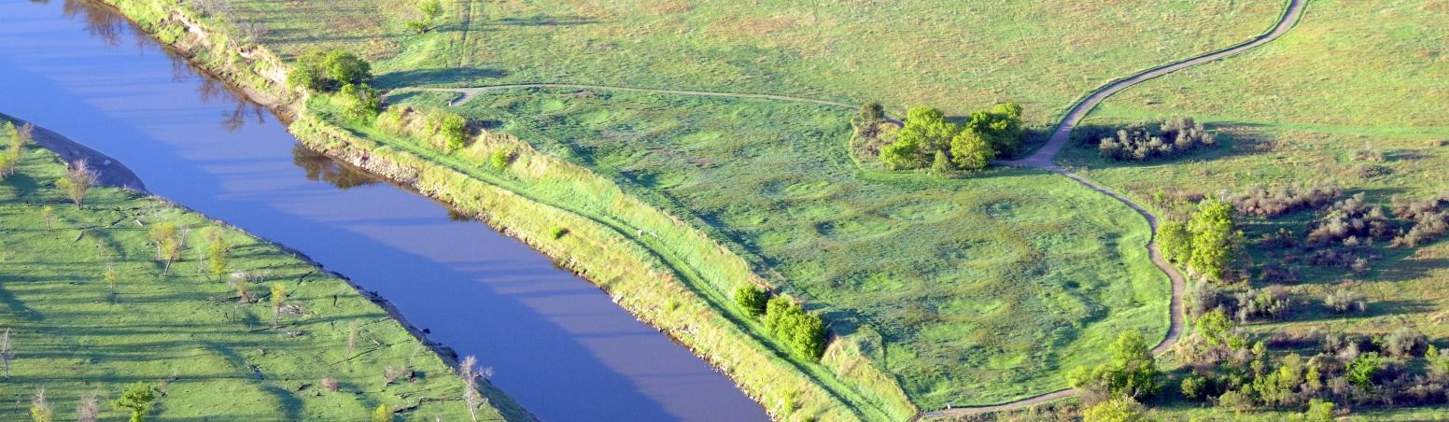

Knife River Indian Villages National Historic Site. National Park Service.

Third, there are cases when excavation is not appropriate. Excavation is a destructive science in that once soil, artifacts, and features are removed they cannot be put back the way they were. Archeologists therefore use drawings, maps, notes, and photographs to record every step of their excavations. Sometimes archeologists choose to not excavate sites at all. This might happen when they find areas such as graves or sacred spaces, or when they wish to preserve features such as earthen mounds for future visitors.

In all of these cases, archeologists often turn to **non-invasive** **geophysical** methods to analyze sites. These techniques allow them to gather multiple kinds of information without having to excavate. Geophysical methods can be either active or passive. **Active** methods produce signals, for example x-rays, that are sent into the Earth. The tools then record the reflected data. **Passive** methods on the other hand rely on the variations of natural forces, such as gravity, to gather information.

**Magnetometry** is one of the most commonly-used passive techniques. This methodology relies on the scientific measuring and mapping of Earth’s magnetic field. Archeologists use this technique to locate, analyze, and preserve sites.

# How Magnetometry Works

Within a bar magnet, the movement of charged electrons creates a magnetic field that surrounds the object. **Magnetic field lines,** showing the field’s direction and strength in teslas (T), meet at the magnet’s north and south **poles**.

Earth, like an enormous bar magnet, has a natural **geomagnetic field** generated by the flow of liquid metal within the planet’s core layers. The strength of the geomagnetic field is measured in nanoteslas (nT).

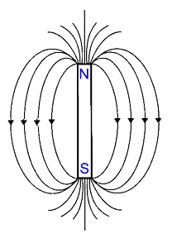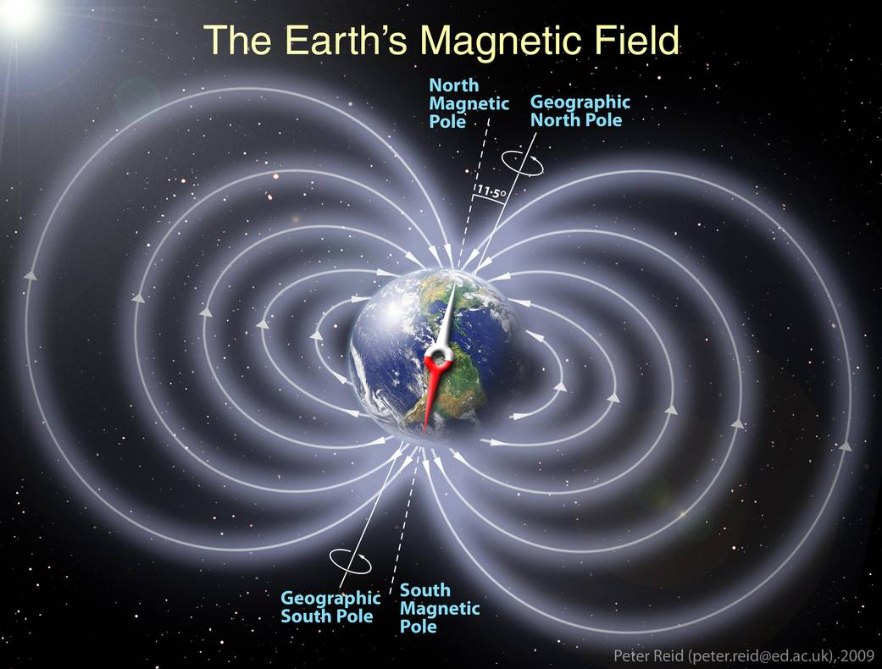

Comparison of magnetic fields around a bar magnet and Earth. NASA.

The strength of the geomagnetic field varies naturally across the planet due to geologic and atmospheric conditions. However, objects within the ground can also cause small differences. Archeologists use **gradiometers** to measure these effects.

There are many types of gradiometers. A **fluxgate gradiometer** contains two sensors stacked on top of each other. Each reads the strength of the geomagnetic field at different heights above the ground. To account for the natural variations of the geomagnetic field, the bottom value is subtracted from the lower value. The difference is equal to the local impact that buried features have upon the geomagnetic field.

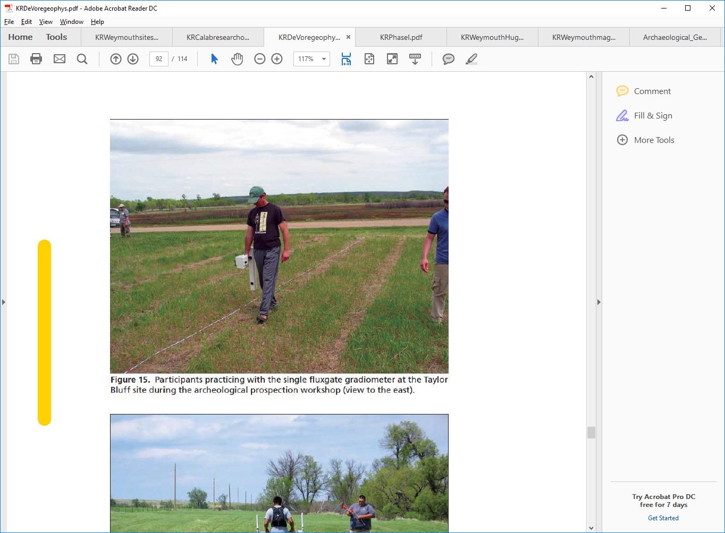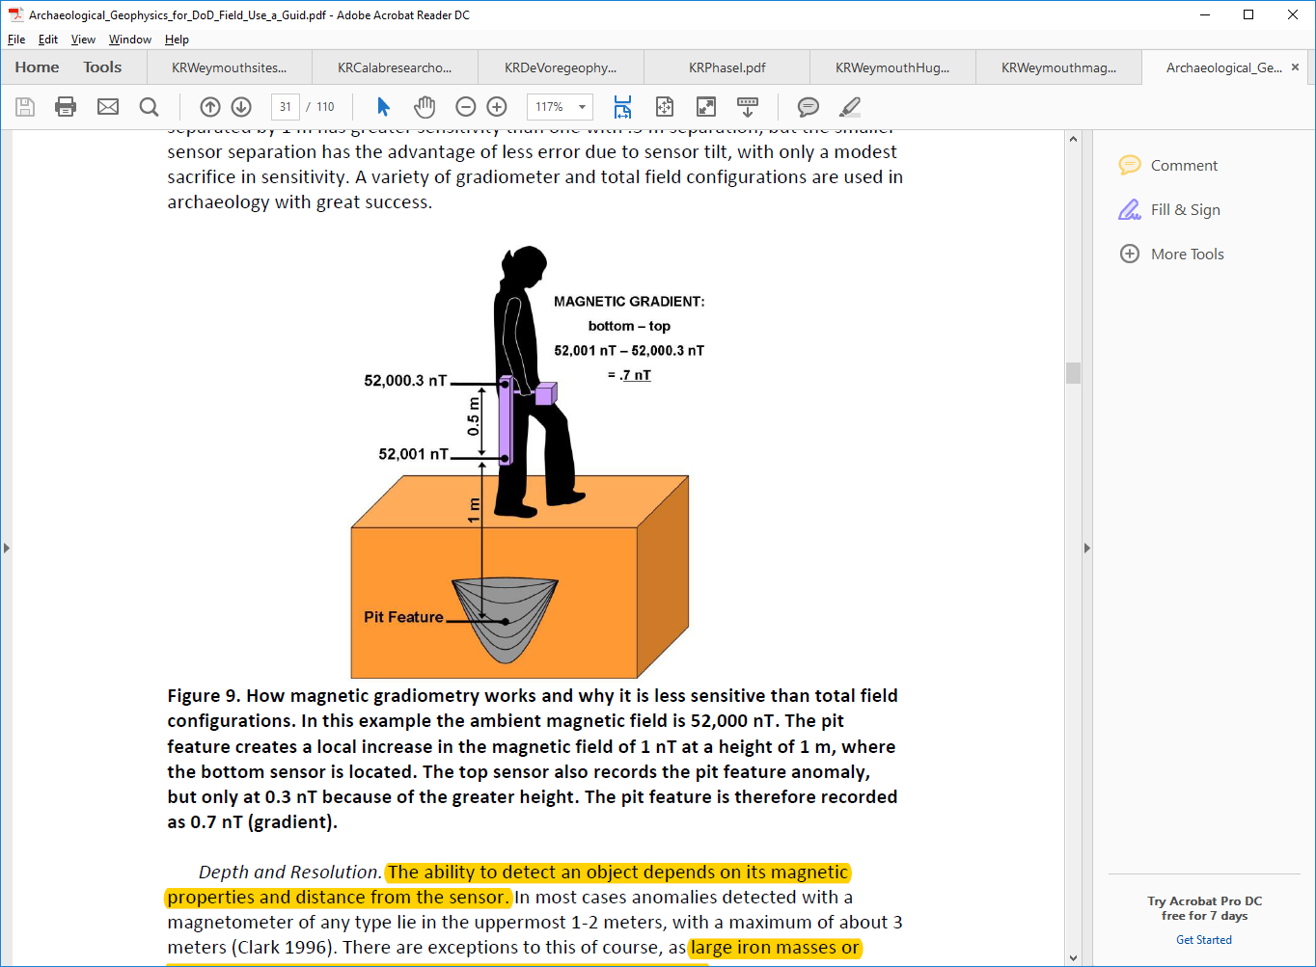

*Using a fluxgate gradiometer. Left: National Park Serivce. Right: Ernenwein, Eileen G. and Michael Hargrave. Archaeological Geophysics for DoD Field Use: A Guide for New and Novice Users. Technical Report. Center for Advanced Spatial Technologies, University of Arkansas Fayetteville and U.S. Army Corps of Engineers, August 2007.*

Archeologists then create maps from the gathered gradiometer data. These maps help archeologists “see” what type of objects may lay buried on a site and their exact locations. On the map below, red, high-value areas show where buried features are more magnetic than the surrounding soil, therefore amplifying the geomagnetic field strength. Blue, low-value areas show features that are less magnetic than the soil. These variations are termed **anomalies**.

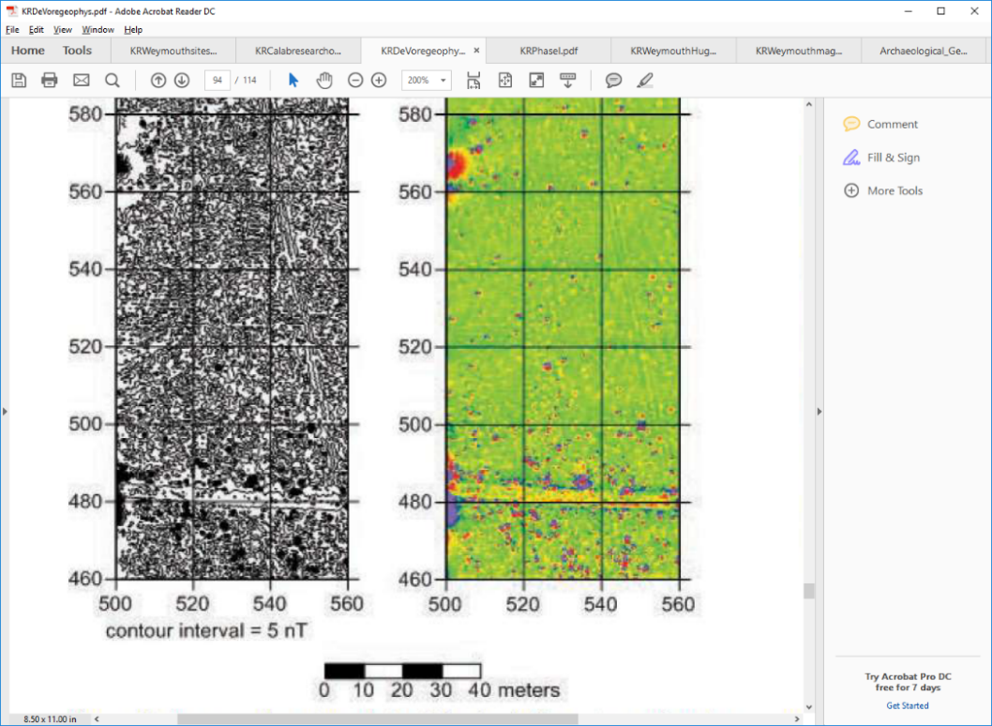

*Maps of magnetometry results showing a linear feature, possibly a road. National Park Service.*

Anomalies can be caused by natural or man-made features. For example, metal objects, hearths or fire pits, and igneous rocks such as magnetite all produce high values. On the other hand, building foundations, compacted floors, and limestone generate lower values. Archeologists use this information to decide which areas of a site they should or should not excavate. When “ground-truthing” excavation is appropriate, it is the most reliable way that archeologists can test their theories about the kinds of objects buried within the soil.

# Case Study: Using Magnetometry at Knife River Indian Villages National Historic Site

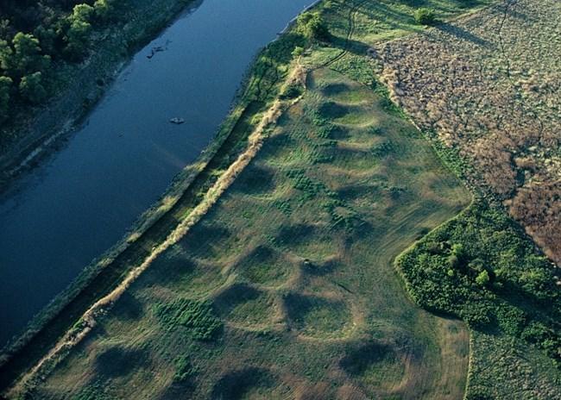 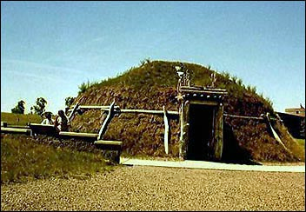Knife River Indian Villages National Historic Site in North Dakota includes four villages that were occupied by Hidatsa peoples over the last 500 years. The sites also have a connection to the famed Lewis and Clark expedition. It was at these villages that fur trader Toussaint Charbonneau and his wife Sacagawea (also spelled Sakakawea) joined the explorers on their multi-year journey westward. Today, the village sites continue to be important for descendants of these Native peoples (who are now part of the Mandan, Hidatsa, and Arikara Nation or Three Affiliated Tribes) as well as others who wish to know more about the sites’ long history.

Left: Earthlodge depressions at Awatixa (or Sakakawea) Village. Right: Reconstructed earthlodge at Knife River Indian Villages National Historic Site. National Park Service.

Native peoples living at these villages in the past built earthlodges that span miles along the river banks. Over time, these fell down and formed depressions in the ground that still exist today. Archeologists can use these depressions and other features to know more about these peoples’ everyday lives. However, archeologists wish to preserve the earthlodge depressions rather than remove them through excavation.

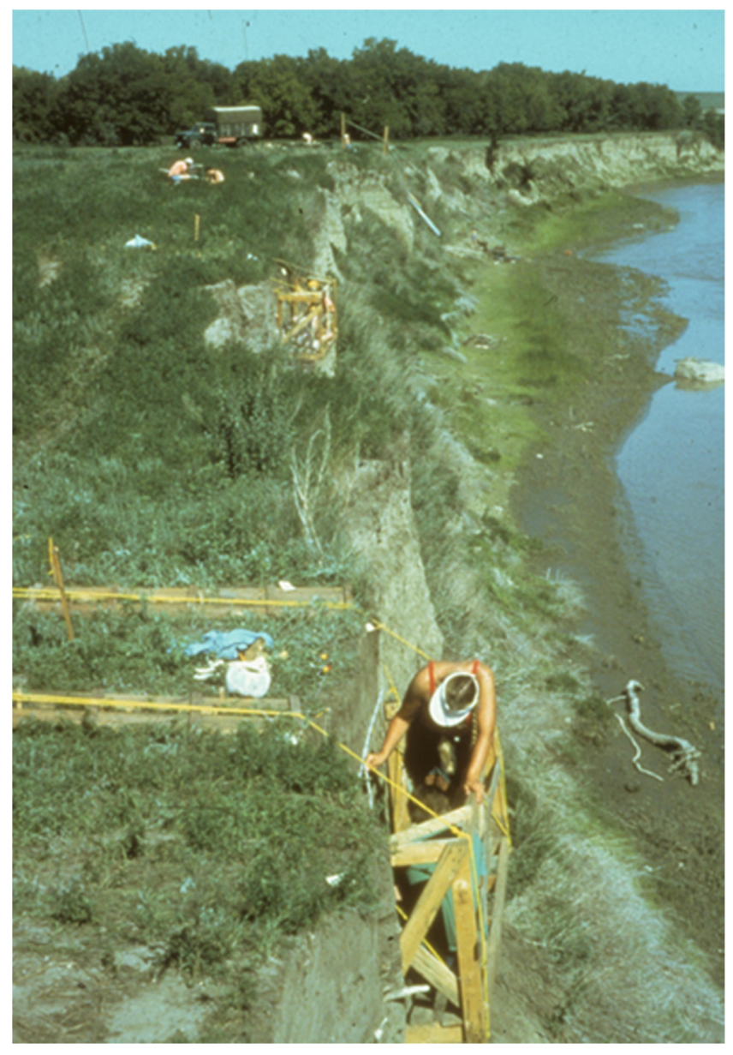

Researcher studying the steep river bank at Awatixa Village. (Cutbank Geophysics: A New Method for Expanding Magnetic Investigations to the Subsurface Using Magnetic Susceptibility Testing at Awatixa Hidatsa Village, North Dakota. Dalan, Rinita et al. In Remote Sensing 9(2) 2017:112.)

To solve this problems, archeologists have turned to non-invasive magnetometry analysis that allowed them to obtain detailed results of buried features while still preserving the sites. Over time many magnetometry surveys have been done at Knife River, with the first occurring in 1976 and most recently in 2012. During that study, archeologists surveyed earthlodge depressions at five village sites including Awatixa Village.

Archeologists first divided the site into survey squares then walked along each with a proton magnetometer. The gathered data was used to create digital maps of the earthlodge depressions. These maps allowed archeologists to view all of the village sites at once rather than in small pieces through sampling excavations.

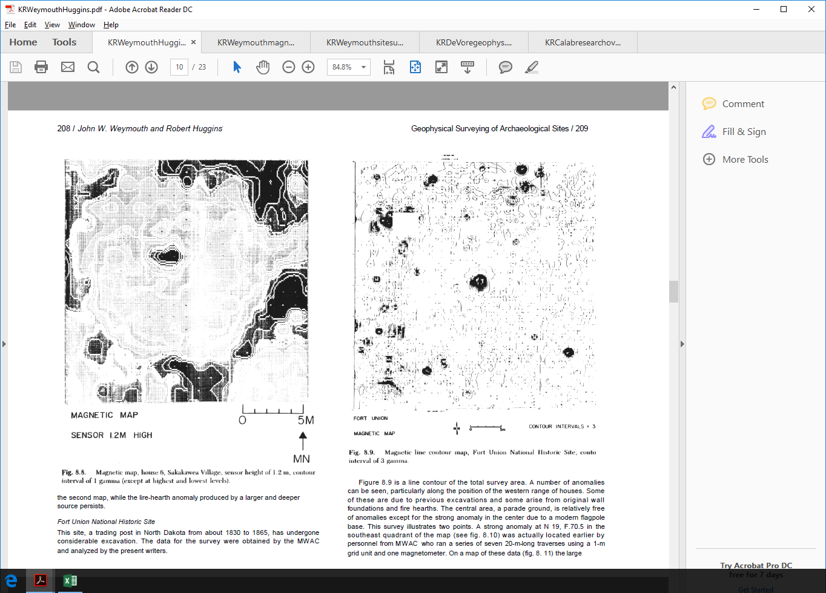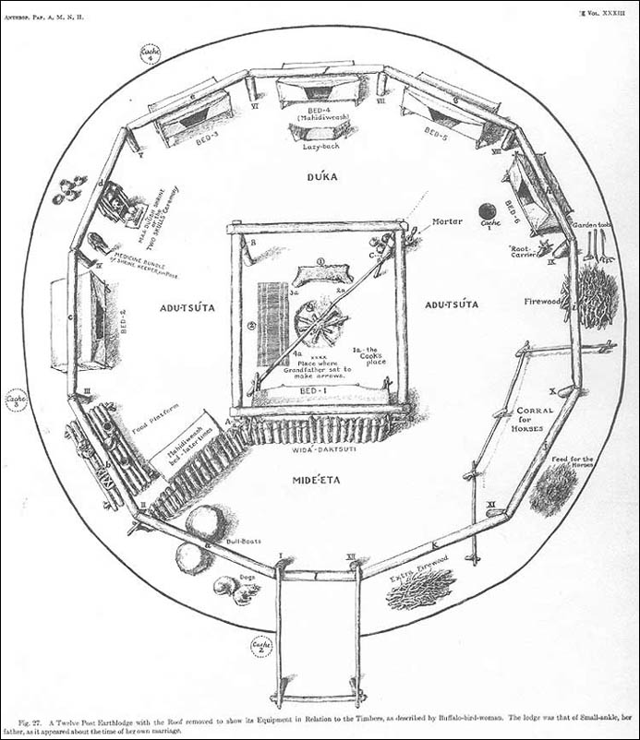

*Left: Map of magnetometry survey results from Sakakawea Village. (Weymouth, John W., Robert Huggins, George Rapp, and John A. Gifford. Geophysical Surveying of Archeological Sites. In Archeological Geology, Yale University Press, 1985, 191-236.) Right: Reconstruction of earthlodge interior showing central hearth. (American Museum of Natural History.)*

In the magnetometry map above, the white circular areas with low magnetic field strength are the packed-down floors within the earthlodges. The high-value black points in their center are the remnants of fire pits where Native peoples cooked meals.

Archeologists used the magnetometry results in three ways. First, by interpreting the patterns within the individual earthlodges, they understood more how Native peoples within the past organized their homes. Second, by using the digital maps to “see” into the ground, archeologists located many earthlodges that were buried over time and were no longer visible on the ground surface. Third, archeologists used the data to create protection plans that will help these incredible sites continue to exist for years to come.